Technical Approach and Capability

Repair and Reseal Parking Lots and Roads
Subtropical Horticulture Research Laboratory USDA-ARS
Miami, Florida

Revision 0

Prepared for:

Greenland Construction & Engineering
Miami, Florida

September 4th, 2020

TABLE OF CONTENTS

PAGE

1. INTRODUCTION ............................................................................................................. 1

2. SITE DESCRIPTION ........................................................................................................ 1

3. QUALITY CONTROL METHODS ..................................................................................... 3

4. INSPECTIONS ................................................................................................................ 5

5. REVISIONS TO WORK..................................................................................................... 5

LIST OF APPENDICES

APPENDIX

PAST PERFORMANCE ………………….…............................................................... A

SITE DRAWINGS ……..………………….…............................................................... B-1

SITE DRAWINGS ……..………………….…............................................................... B-2

1. INTRODUCTION

Greenland Construction & Engineering is please to submit this Technical Approach and Capability to demonstrate our ability to perform on the Repair and Reseal Parking Lots and Roads (RFP#12405B20R0035). Greenland Construction & Engineering is an 8(a) and Small Business Certified NAICS 237210.

Greenland Construction & Engineering has completed over 250 projects in our 14-year history -many of these projects have been in the South Florida area. This project is located approximately 20 minutes from our office.

Greenland Construction & Engineering understands the market and our project team has over 75 years of road repair experience. Our project team will be managed by Ariel Diaz, sole Owner/President of Greenland Construction & Engineering, Rolando Arrieta Superintendent.

The project superintendent Rolando Arrieta has many years of supervisory road repair experience leading project teams. If awarded, Ariel Diaz will on the project daily and lead the Greenland team.

During the past three years, Greenland Construction & Engineering has been awarded multiple projects that are nearly identical scopes of work, size and complexity as the Repair and Reseal of the parking lots and roads.

2. SITE DESCRIPTION

The project is located USDA, ARS, Subtropical Horticulture Research Station located on 13601 Old Cutler Road Miami, Fl 33158. Greenland Construction & Engineering was able to visit the site on August 26th, 2020 and discuss the project with POC Karla Agurto, Administrative Officer.

The primary potential human health risk associated with the site is the direct exposure of dust to the building occupants at the site. The site contains no contaminated fill material that is known to the contractor at this time. The underlying groundwater generally does not pose a health risk to the residents because the area has a public water source, and the site groundwater is not used for drinking or other domestic purposes.

The contract includes work at the grounds of the USDA, ARS, Subtropical Horticulture Research Station. In August 21st, 2020, the USDA issued a scope of work entitled, Repair and Reseal Parking Lots and Roads. The SOW states the contractor shall provide and perform the following services:

Item #1: Base Bid Option 1: Parking lots for B89 and B28.
- The Contractor shall sweep, clean, and power blow surface to remove all dirt, debris, and loose material from parking area.
- The contractor will then apply Sealmaster, or equivalent, commercial grade ultra-high blend asphalt tar emulsion in one coat with approximate coverage rates between 1.5 to 2.5 gallons per 75 sq.ft.
- Contractor will add visitors parking decal to one parking space as specified by Site personnel and repaint 2 handicap parking decals to meet code. Lines for all parking spaces will be
painted white. Contractor will clearly mark the one visitor space with green lines and a visitor decal as directed during site visit.
- The contractor will cut and remove the existing root damage from existing asphalt. All roots causing asphalt damage will be cut with a chain saw 5-7 feet from the tree and left in place. The damaged asphalt will be removed and replaced using lime-rock base and compact to 98% density and new asphalt will be placed in the damaged areas that encompass an estimated area of 169 sq. feet.
- Contractor will also remove and replace one damaged parking bumper.
- The estimated area of the parking lots is 13,950 sq. ft. by the ARS measurements.
- Appendix B1

Line Item #2: Option 2: Repair all roads highlighted in orange and light blue on the provided drawing.
- Repair three (3) major cracks observed during the site visit. The damaged road will be cut and removed and filled using lime-rock base and compact to 98% density and new asphalt will be placed in the damaged areas that encompass an estimated area of 6’ X width of the existing road.
- Repair 3 undulations observed during the site visit. Uneven and sunken areas will filled using lime-rock base and compact to 98% density and patched with new asphalt.
- Reseal the road with Sealmaster, or equivalent, commercial grade ultra-high blend asphalt tar emulsion in one coat with approximate coverage rates between 1.5 to 2.5 gallons per 75 sq.ft. in area delineated by orange and light blue highlighting on attached drawing. The estimated area of all roads is 211200 sq. ft. by ARS measurements.
- Appendix B1

Line Item #3: Option 3: Repair all roads highlighted in light blue on the provided drawing only.
- Repair potholes and cracks. The damaged road will be cut and removed and filled using lime-rock base and compact to 98% density and new asphalt will be placed in the damaged areas that encompass an estimated area of 5’ X width of the existing road.
- Reseal the road with Sealmaster, or equivalent, commercial grade ultra-high blend asphalt tar emulsion in one coat with approximate coverage rates between 1.5 to 2.5 gallons per 75 sq.ft. in area delineated by light blue highlighting on attached drawing. The estimated area of all light blue indicated roads is 24288 sq. ft. by ARS measurements.
- Appendix B1

Line Item #4: Edging of Grass
- As discussed during the site visit, the edging of the grass adjacent to the road is highly recommended. The growing grass along the edge will prevent the sealant from ending at the end of the road causing the road to remain unprotected at the ends.
- Contractor is able to provide edging of the grass along the road.

Line Item #5 Proposed Main areas – Parking lots for B89 and B28 and Circumference of Main Building
- The Contractor shall sweep, clean, and power blow surface to remove all dirt, debris, and loose material from parking area.
- The contractor will then apply Sealmaster, or equivalent, commercial grade ultra-high blend asphalt tar emulsion in one coat with approximate coverage rates between 1.5 to 2.5 gallons per 75 sq.ft.
- Contractor will add visitors parking decal to one parking space as specified by Site personnel and repaint 2 handicap parking decals to meet code. Lines for all parking spaces will be
painted white. Contractor will clearly mark the one visitor space with green lines and a visitor decal as directed during site visit.
- The contractor will cut and remove the existing root damage from existing asphalt. All roots causing asphalt damage will be cut with a chain saw 5-7 feet from the tree and left in place. The damaged asphalt will be removed and replaced using lime-rock base and compact to 98% density and new asphalt will be placed in the damaged areas that encompass an estimated area of 169 sq. feet.
- Contractor will also remove and replace one damaged parking bumper.
- The estimated area of the parking lots is 13,950 sq. ft. by the ARS measurements.
- Reseal the road with Sealmaster, or equivalent, commercial grade ultra-high blend asphalt tar emulsion in one coat with approximate coverage rates between 1.5 to 2.5 gallons per 75 sq.ft. in area delineated by light blue highlighting on attached drawing. The estimated area of all green indicated roads is 29,910 sq. ft. by ARS measurements.
- Appendix B2

Protection of Work and Property/Safety:

Safety and health matters, including complying with local Covid-19 requirements, as they relate to the work, are the exclusive responsibility of the Contractor. The Contractor shall furnish, erect, and maintain barricades, warning lights, signs, guards, or take other precautions as may be required by law or local authorities of the protection and security.

Temporary Facilities:
Contractor is responsible for providing sanitary services for its employees.

Clean-up:
The construction site shall be kept clean and free of debris at all times. Restore areas disturbed as nearly as possible to the original appearance and condition. Upon completion of the project, and prior to final inspection, the Contractor shall remove from the premises all unused material, trash, and debris resulting from the work to the satisfaction of the COR.

3. QUALITY CONTROL ORGANIZATION

The Contractor’s key personnel assigned to this project should possess a broad range of construction experience and skills. All should have experience working on federal construction sites and should be familiar with requirements of day-to-day work under this contract.

The functional responsibilities of key technical personnel are summarized as follows.

Ariel Diaz – President - On-site Project Manager
The Contractor’s President will ultimately be responsible for the project's success. He will provide the required resources to ensure that the project is successfully executed. He will be kept informed of the project's progress and maintain that the project is meeting its goals. The President will also serve as the acting Project Manager and will resolve problems that cannot be resolved by the On-site Job Superintendent or Quality Control Manager.

The Contractor’s field personnel should rely on home office support throughout the course of the project. The Contractor’s on-site Project Manager will become and remain personally involved until each problem is resolved and appropriate corrective measures are implemented. He will typically communicate at least once daily on the progress of the project. The Project Manager will be present on the jobsite, to ensure that the project is progressing as scheduled.

The On-site Project Manager is responsible for implementation and support of the Contractor’s CQCP and will oversee all aspects of work under this contract for remediation at the site, including:

- All procurements.
- Qualified Contractor and subcontractor resources are assigned to the project and balanced to ensure jobs are aligned with project needs.
- The Site is maintained and secure.
- All tasks are carried out safely and in compliance with the project specifications.

His responsibilities include:

- Contractor coordination.
- Acting as site liaison between the Contractor and USDA.
- Maintaining charge of all field operations.

Rolando Arrieta – Superintendent
The project Superintendent will be responsible for supervising all field activities. His duties include supervision of the craft labor (equipment operators, truck drivers, and laborers), technical staff (survey crew), and all subcontractors. The designated Superintendent is also responsible for the maintenance of all on-site construction equipment.

The superintendent will also serve as the transportation and disposal coordinator. He/she will be responsible for escorting all vehicles to and from the project location as per the approved traffic route. He/she will also be responsible for disposal of all construction and demolition (C&D) waste.

Maria Martinez - Site Safety and Health Officer (SSHO)
The Site Safety and Health Officer will report to the Director of Health and Safety and be responsible for the implementation of the approved Site Health and Safety Plan; including conducting required safety inspections, safety briefings, and reports of safety-related activities.

Safety and health matters, including complying with local Covid-19 requirements, as they relate to the work, are the exclusive responsibility of the Contractor. The Contractor shall furnish, erect, and maintain barricades, warning lights, signs, guards, or take other precautions as may be required by law or local authorities of the protection and security.

4. INSPECTIONS

To ensure that all construction and remedial activities comply with the project specifications, the QCM will complete, in conjunction with the subcontractors, three phases/items of site inspections for each feature of work. The Prepatory and Initial Phase Inspections will be tracked using Appendix B, Initial/Follow Up Phase Inspection Checklist. All open items will be tracked until completion. The Contracting Officer will be notified at least 48 hours in advance of the commencement of the prepatory and initial phases.

5. REVISIONS TO WORK

The Contractor will be responsible for ensuring total compliance of field work to the project specifications. Should modifications or revisions to the specifications become necessary, the Contractor will make the request, in writing, to DOC CO/CE. Approval from DOC CO/CE must be received prior to allowing the modifications or revisions to be made in the field.

6. PAST PERFORMANCE

#1
Department of Homeland Security
United States Coast Guard Civil Engineering Unit
16001 SW 117th Ave, Richmond Heights, FL 33137
- Project: USCG ADA Parking Space CEU Facilities in Richmond Heights, FL.
- Contract Value: $10,999
- Scope of Work: Installment of a Disability parking space at the US Coast Guard. Demolition and grading of existing grounds to build a brand-new parking space to adhere to ADA compliance. Sealed and striped the space.
- Timeliness of Performance: Completed on time
Point of Contact: James Barone
Email: James.A.Barone@uscg.mil
Telephone: (786) 599-1865

#2
Florida Profit Corporation
US 27 Truck Parking Corp
1449 NW 117th Ave, Miami, FL 33018
- Project: Truck Parking
- Contract Value: $ 2,000,000
Scope of Work: Full development and construction of a truck stop and parking lot over 26 acres of undeveloped property.
- Timeliness of Performance: Completed on time
Point of Contact: Milexis & Ulises Fernandez
Email: milexisf@gmail.com
Telephone: (305) 219-2045

#3
Federal Emergency Management Agency (FEMA)
Howard Havens Mobile Home Park
3153 Avenue C
Big Pine Key, FL 33043
- Project:
- Contract Value: $196,400
- Scope of Work:
- Timeliness of Performance: Completed on time
Point of Contact: John Clemens
Email: john.clemons@fema.dhs.gov
Telephone: (770) 220-8837

Appendix B-1

Site Drawing Provided by USDA-ARS

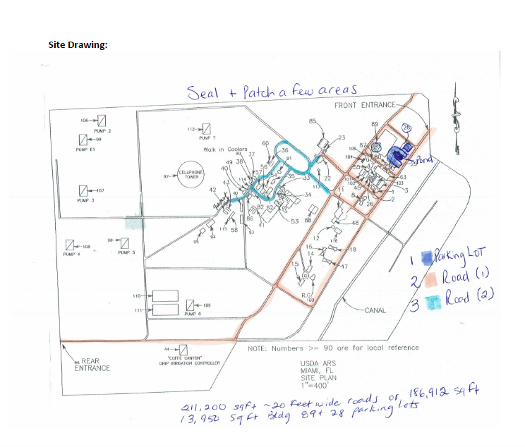

Appendix B-2

